4.7 Worksheet Name________________________________________________________Date___________________Per____

Write an equation in **point-slope form**.

1) Point (1, 2) and has a slope of 4. 2) Point (−7, 3) and has a slope of ½.

Write an equation in **slope-intercept form**.

3) Point (−2, −5) and has a slope of −12. 4) Point (4, 2); slope = 3

5) Points (3, 4) and (0, 5) 6) Point (1, −7); slope = −1

7) Points (2, −2) and (0, −1) 8) Point (−8, 6); slope = ¼

9) Points (1, 3) and (−3, −5) 10) (6, −6); slope = ⅚

11) Points (3, 3) and (1, −3) 12) Point (−2, −11); slope = 4

13) Points (−1, 4) and (0, 1) 14) Points (5, −2) and (3, 2)

Graph each equation.

15)  16) 

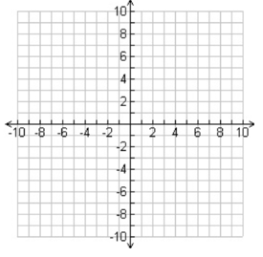

17)  18) 

Convert the following equations from point-slope form into slope-intercept form and general form.

19)  20)  21) 

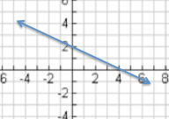

22) Write an equation in point-slope form for the line given.